**AI Assisted Coding**

# Assignment Number : 5.5

**Name : Saniya Begum**

**H.no : 2303A52351**

**Batch : 34**

**Lab 5**: Ethical Foundations – Responsible AI Coding Practices **Lab Objectives:**

* To explore the ethical risks associated with AI-generated Week3 - code.
* To recognize issues related to security, bias, transparency, and copyright.
* To reflect on the responsibilities of developers when using AI tools in software development.
* To promote awareness of best practices for responsible and ethical AI coding.

**Lab Outcomes (LOs):**

After completing this lab, students will be able to:

* Identify and avoid insecure coding patterns generated by AI tools.
* Detect and analyze potential bias or discriminatory logic in AI-generated outputs.
* Evaluate originality and licensing concerns in reused AI- generated code.
* Understand the importance of explainability and transparency in AI-assisted programming.
* Reflect on accountability and the human role in ethical AI coding practices.

## Task Description #1 (Transparency in Algorithm Optimization)

Task: Use AI to generate two solutions for checking prime numbers:

* Naive approach(basic)
* Optimized approach Prompt:

“Generate Python code for two prime-checking methods and explain how the optimized version improves performance.”

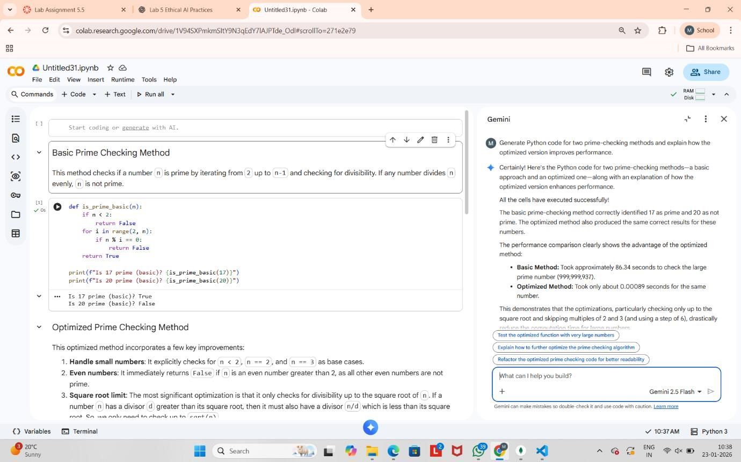

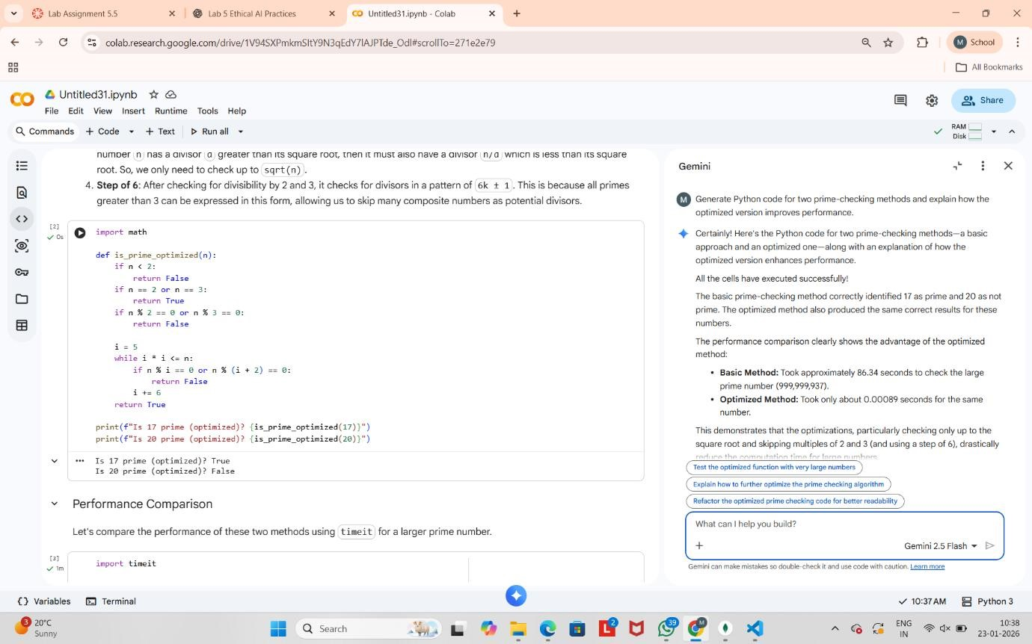

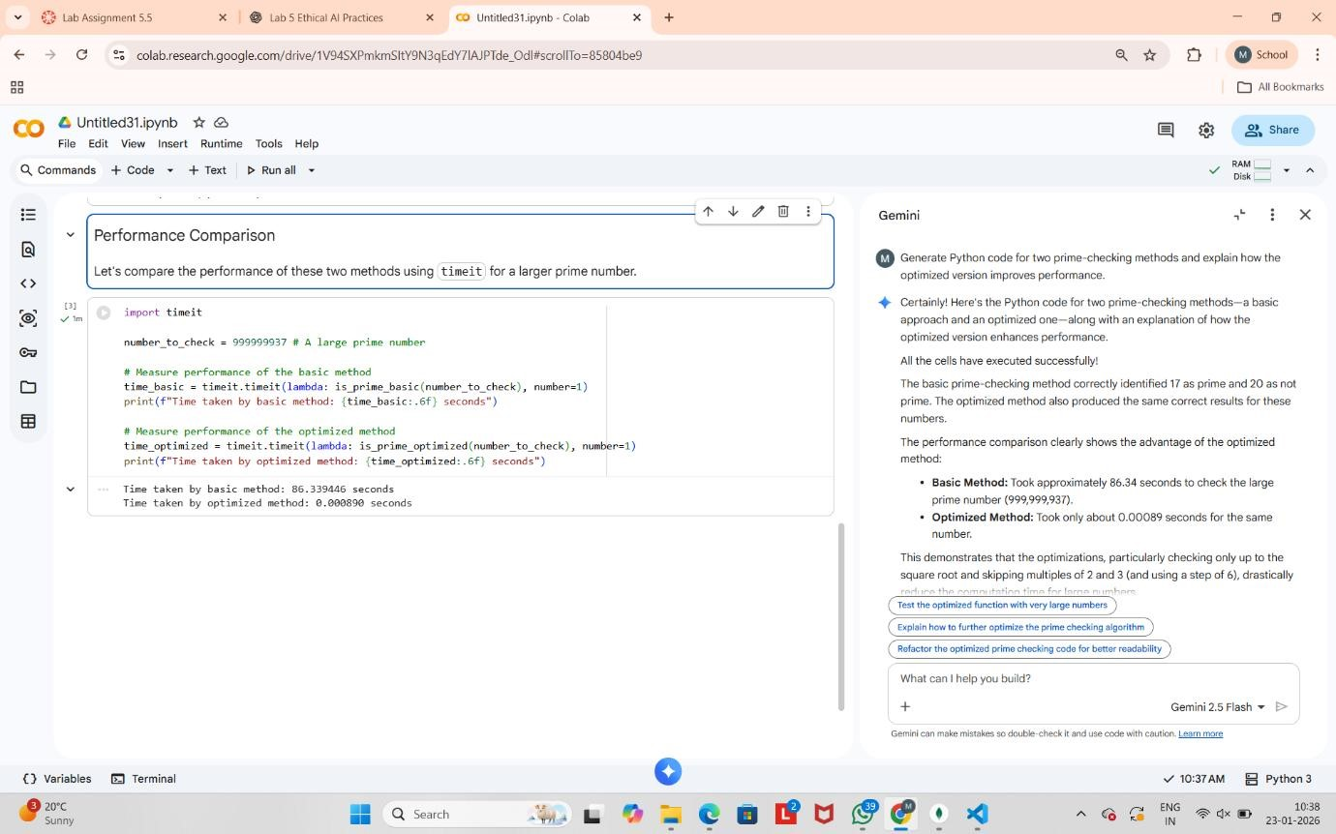

## Task Description #2 (Transparency in Recursive Algorithms)

Objective: Use AI to generate a recursive function to calculate Fibonacci numbers.

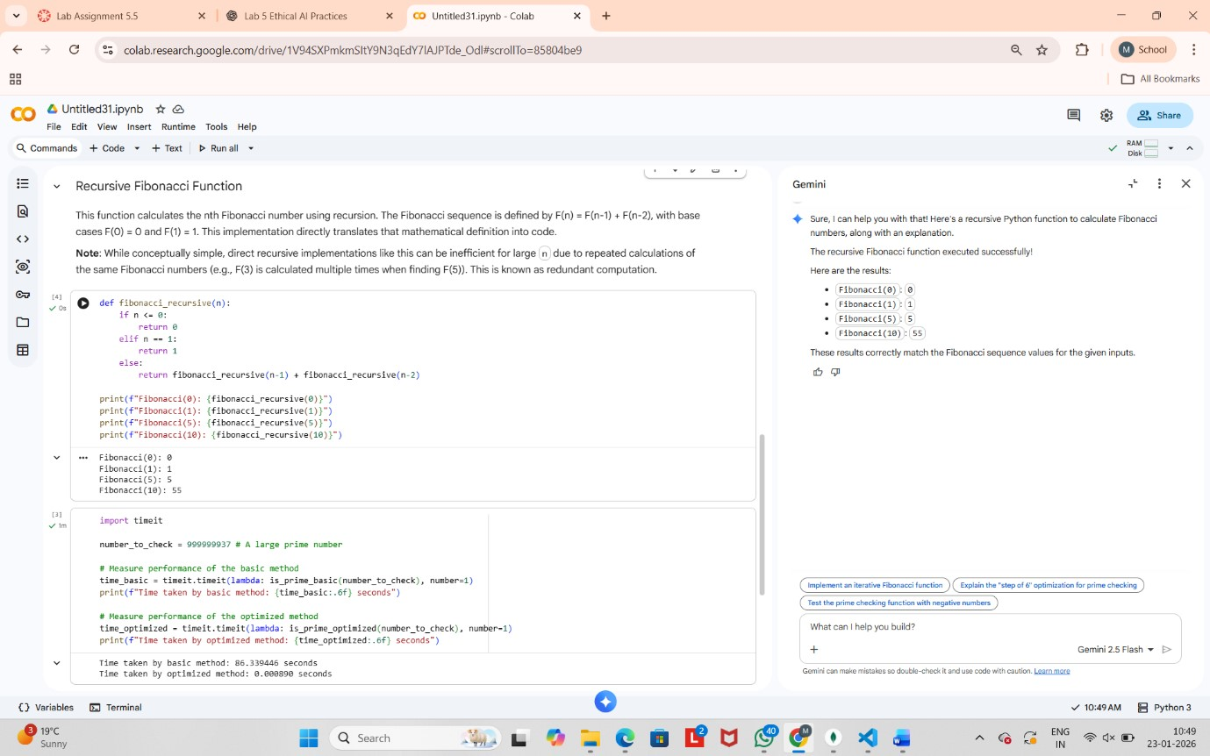

## Task Description #3 (Transparency in Error Handling)

Task: Use AI to generate a Python program that reads a file and processes data.

Prompt:

“Generate code with proper error handling and clear explanations for each exception.

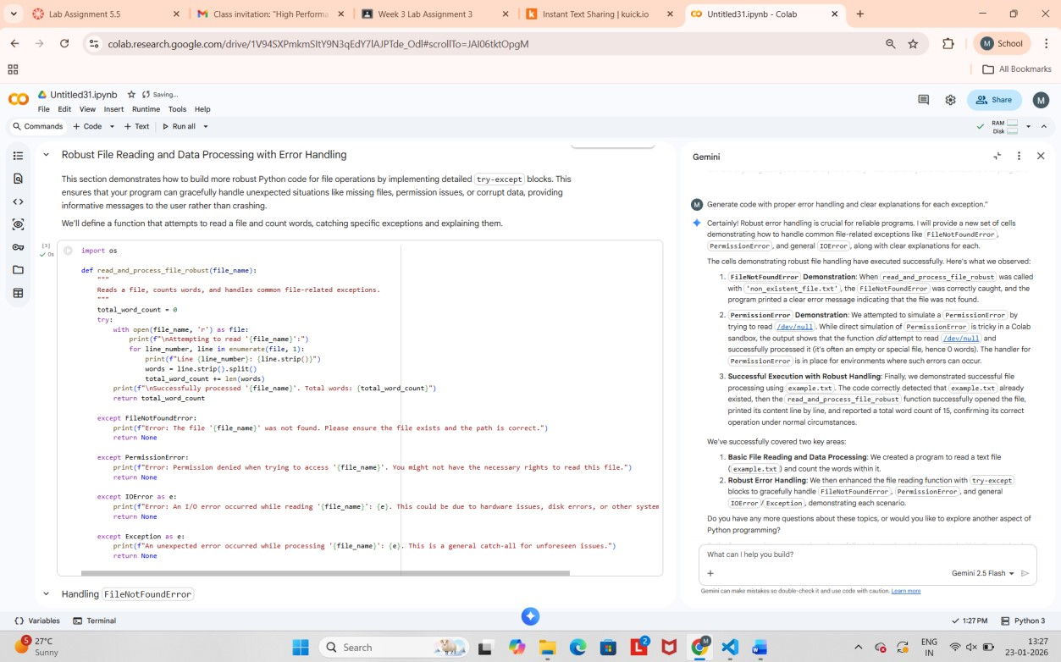

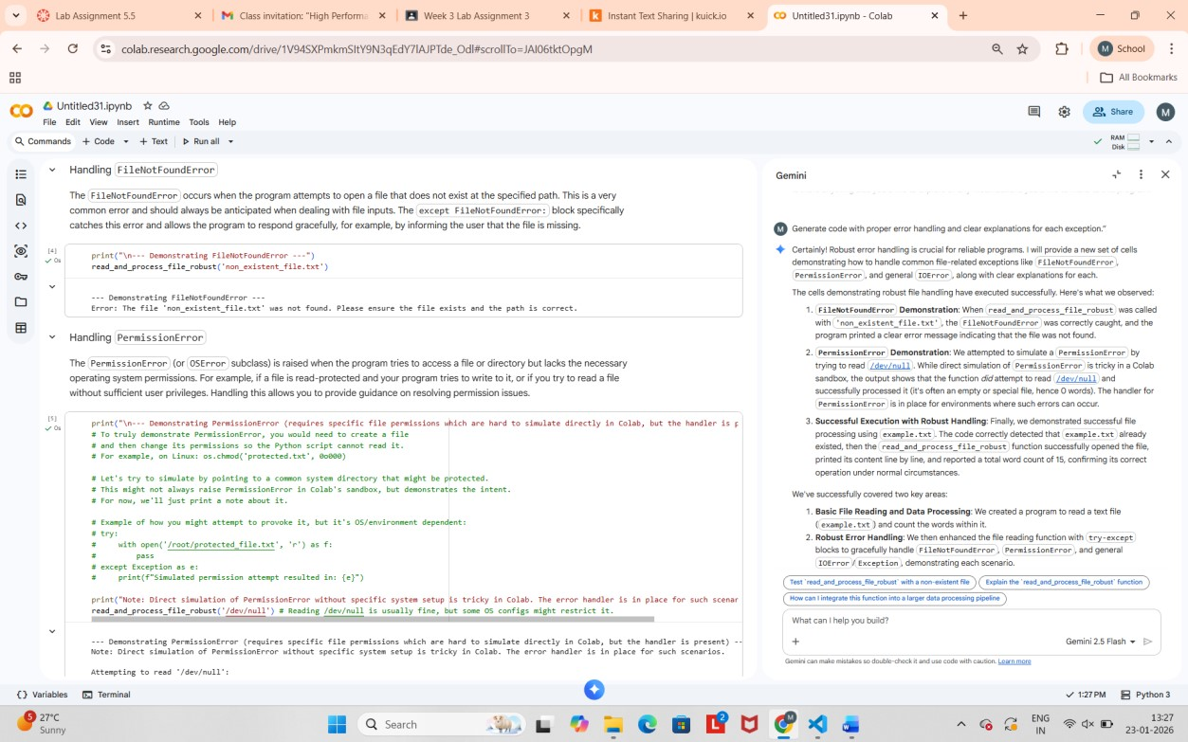

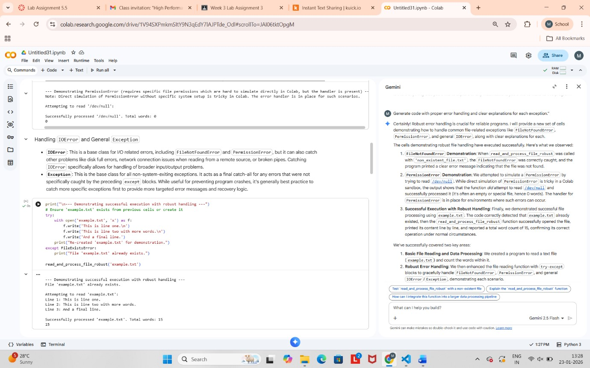

## Task Description #4 (Security in User Authentication)

Task: Use an AI tool to generate a Python-based login system. Analyze: Check whether the AI uses secure password handling practices.

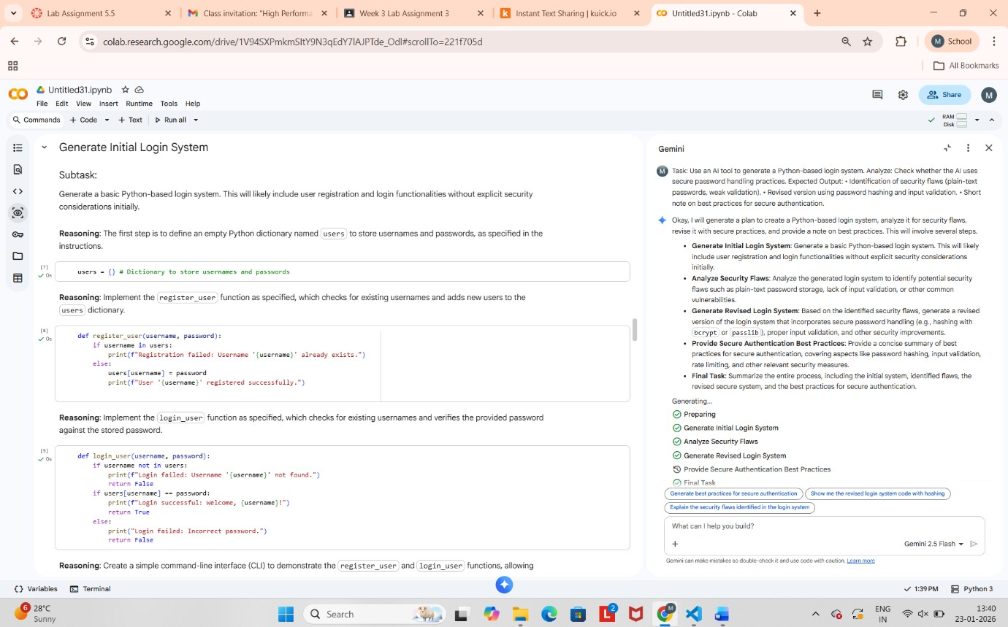

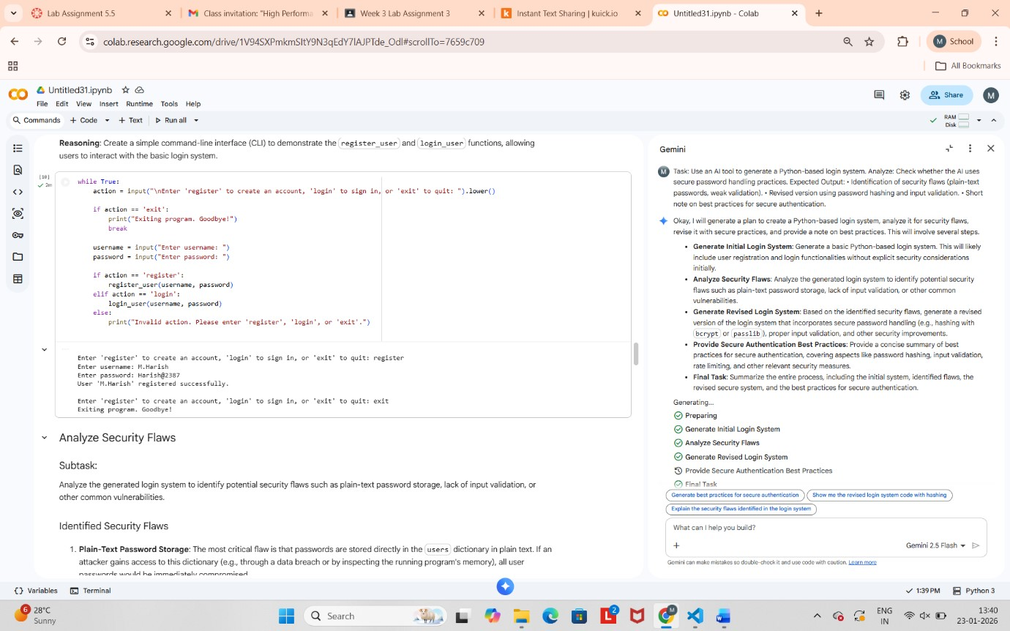

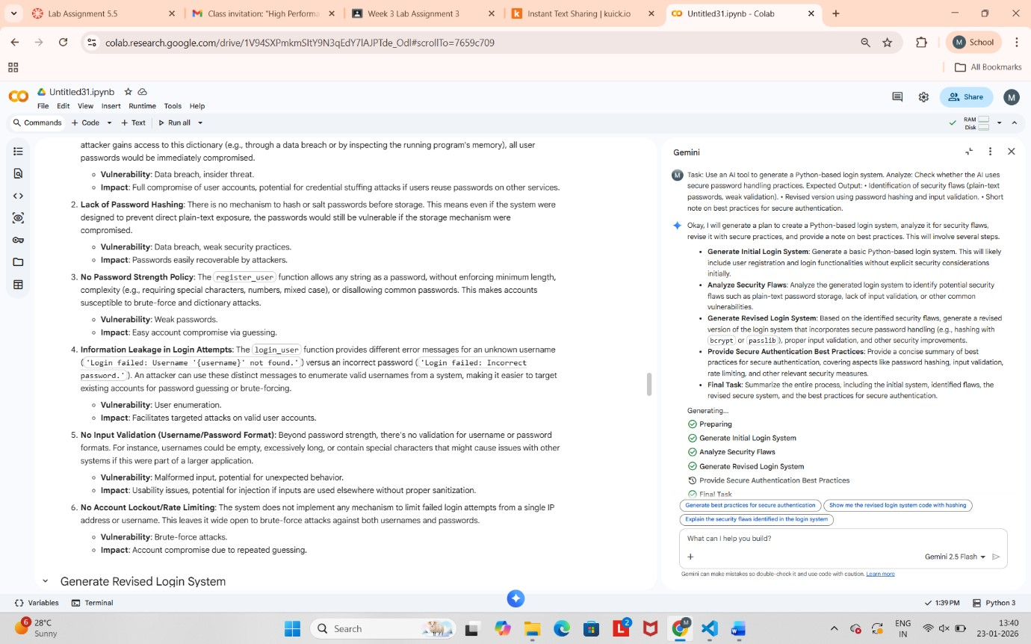



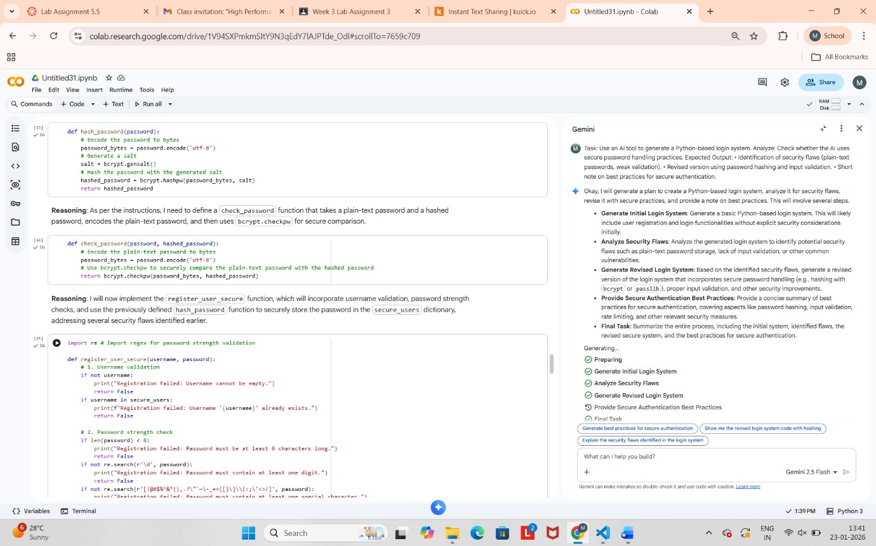

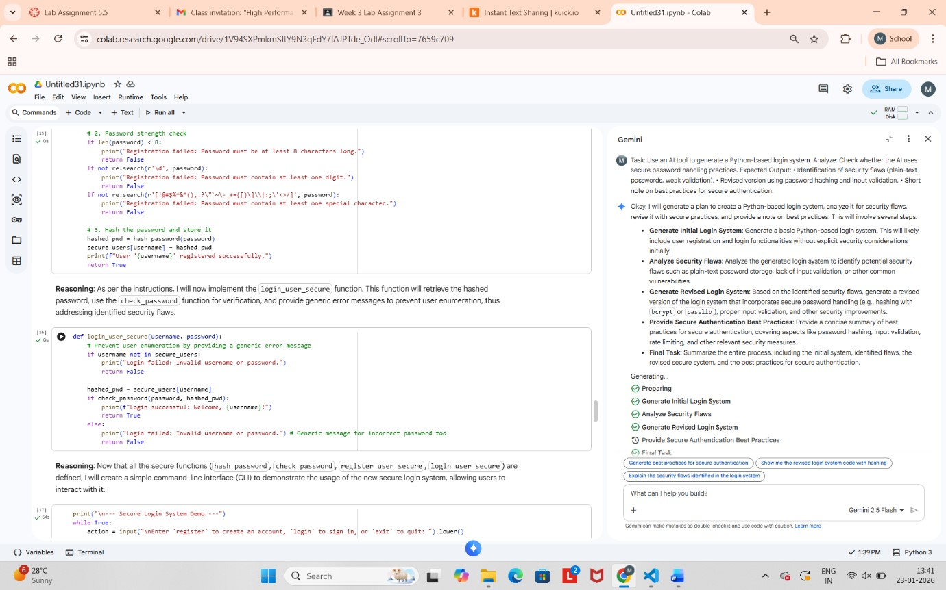

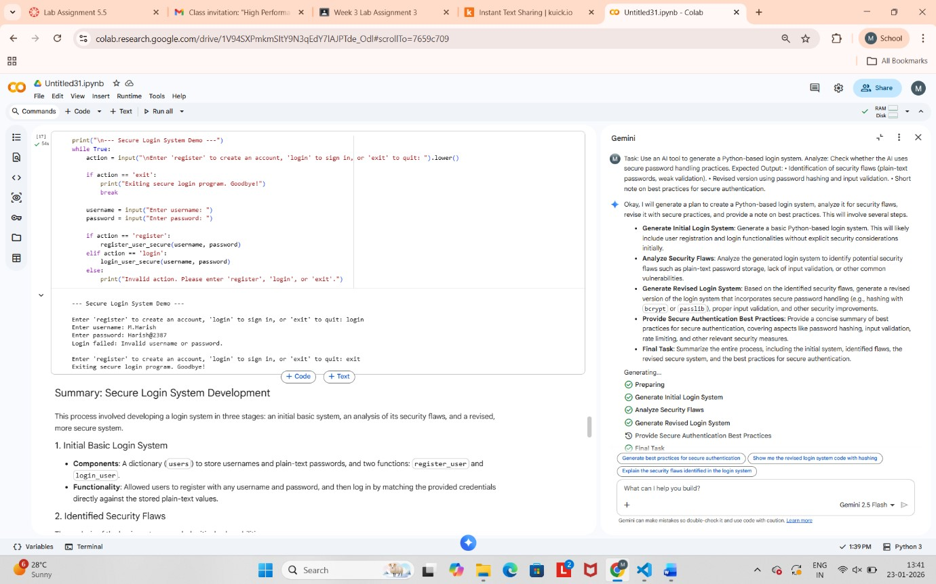

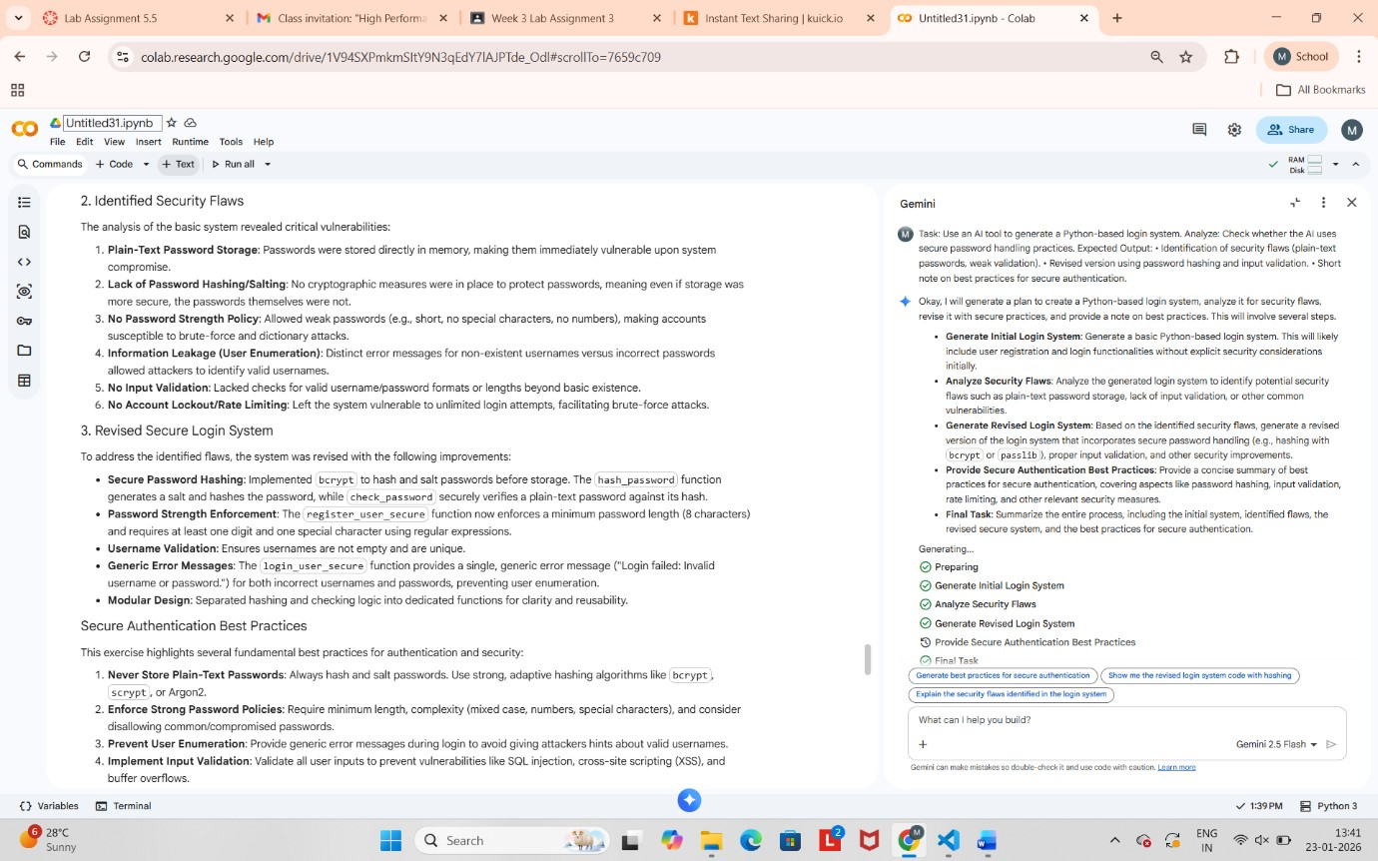

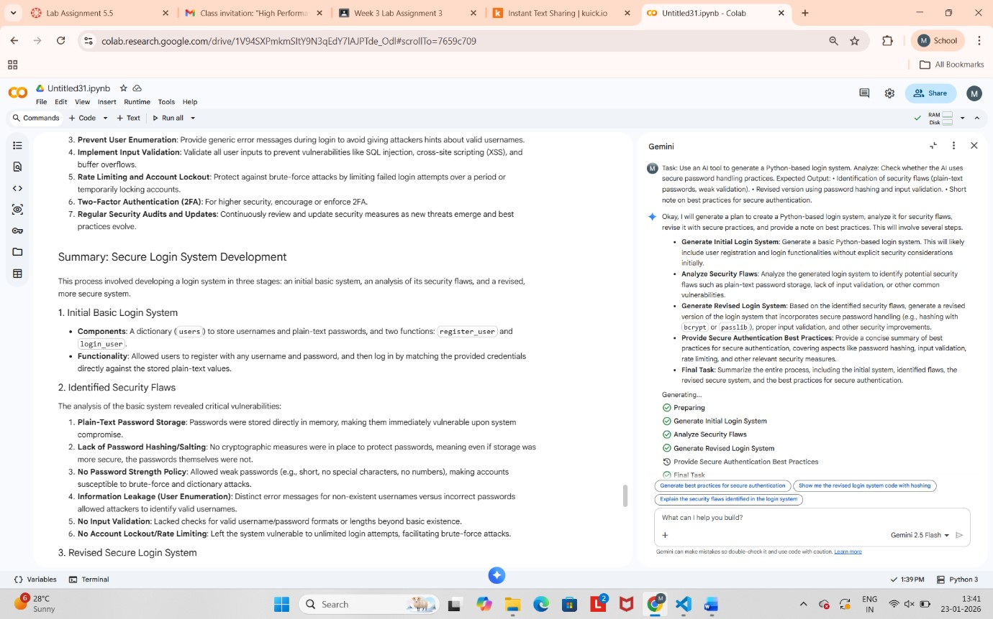



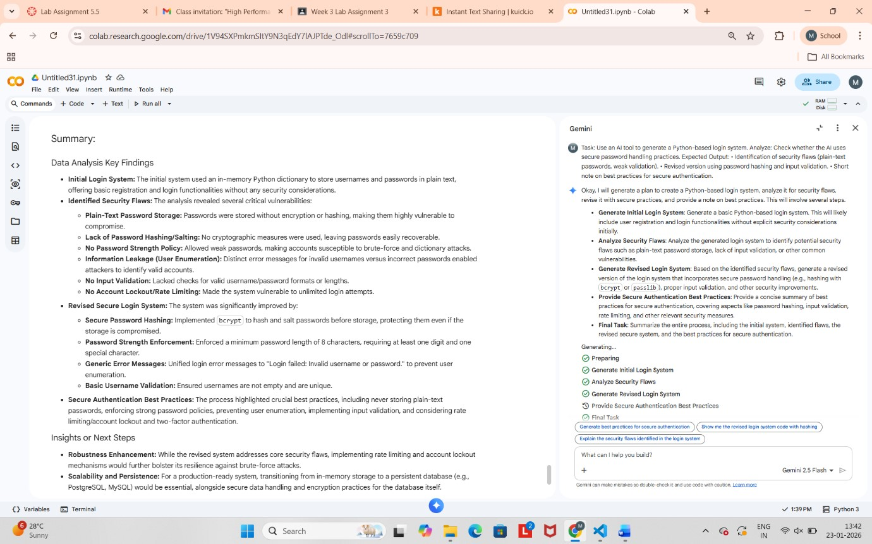

## Task Description #5 (Privacy in Data Logging)

Task: Use an AI tool to generate a Python script that logs user activity (username, IP address, timestamp).

Analyze: Examine whether sensitive data is logged unnecessarily or insecurely.

